Alex Stevens

Business Card Project

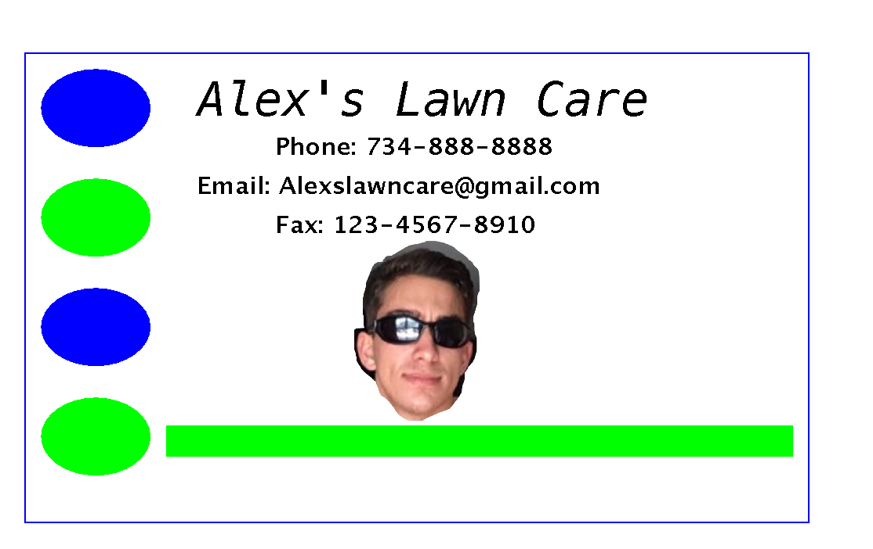

I pledge that this work is entirely mine, and mine alone (except for any code provided by my instructor).

I spent a 2 hours working on this project from start to finish. I worked on it between September 8 and September 10.

// ALEX STEVENS Project 1

import javax.swing.\*;

import java.awt.\*;

import java.awt.image.\*;

import javax.imageio.\*;

import java.io.\*;

public class Drawing extends JPanel{

public static void main() {

JFrame f = new JFrame();

f.setContentPane(new Drawing());

f.setSize(600 , 400);

f.setVisible(true);

}

public void paintComponent(Graphics g){

// this statement required

super.paintComponent(g);

// optional: paint the background color (default is white)

setBackground(Color.WHITE);

// contact info

Font myFont1 = new Font("sanserif", Font.BOLD,15);

g.setFont(myFont1);

g.drawString("Phone: 734-888-8888", 200,125);

g.drawString("Email: Alexslawncare@gmail.com", 150, 150);

g.drawString("Fax: 123-4567-8910", 200, 175);

Font myFont = new Font("monospaced", Font.ITALIC,30);

g.setFont(myFont);

g.setColor(Color.black);

g.drawString("Alex's Lawn Care", 150, 100);

// draw a solid and empty rectangle

g.setColor(Color.BLUE);

g.drawRect(40, 60, 500, 300);

// ovals on the side

g.setColor(Color.BLUE);

g.fillOval(50, 70, 70, 50);

g.setColor(Color.GREEN);

g.fillOval(50, 140, 70, 50);

g.setColor(Color.BLUE);

g.fillOval(50, 210, 70, 50);

g.setColor(Color.GREEN);

g.fillOval(50, 280, 70, 50);

// box at the bottom

g.fillRect(130, 298, 400, 20);

// picture logo

BufferedImage photo = null;

try {

File file = new File("face1.jpg");

photo = ImageIO.read(file);

} catch (IOException e){

}

g.drawImage(photo, 250, 180, 80, 115, null);

}

}